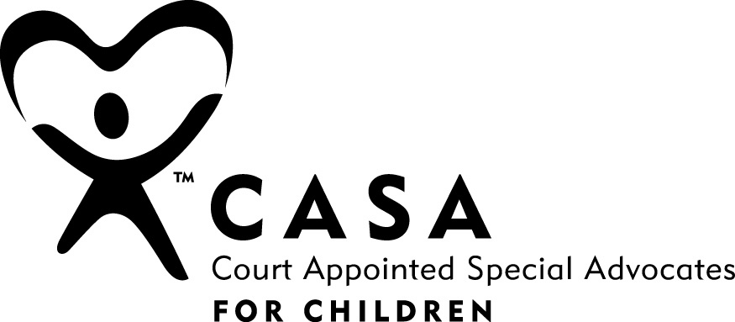
Court Appointed Special Advocates of Rochester/Monroe County, Inc.
Elizabeth Caldwell, Executive Director
Family Court of the State of NY • 272 Hall of Justice • Rochester, NY 14614

Phone: 585-371-3980• Fax: 585-371-3986 • Email: casa@casarochester.org • Web: casarochester.org

SCHOOL QUESTIONNAIRE

CASA contact: ________________________________ Request date: ___________________________
Child’s name: _________________________________ DOB: ______________________
CASA Court assignment sheet or parental consent: attached _____ on file _____ faxed _____
Child’s adult resource: _________________________________
Date of form completion: ______________ Person completing form: _____________________________
School: ________________________________________ Phone #: ______________________
Address: _________________________________________________________________________________
- Please attach a written record of the academic progress of this child for the current school year, as well as an attendance record.
- Please attach any IEP plans, 504 plans, and/or educational evaluations.

- Please comment on the behavior of this child in school:
_______________________________________________________________________________________________________________________________________________________________________________________________________________________________________________________________
(Circle “biological” or “foster” for the following question.)
- Please comment on the responsiveness of this child’s biological / foster parent(s) to school concerns and activities:
_______________________________________________________________________________________________________________________________________________________________________________________________________________________________________________________________

- Is attendance a barrier to this child’s academic progress?
______________________________________________________________________________

- Please list any specific concerns you have related to this child:
_______________________________________________________________________________________________________________________________________________________________________________________________________________________________________________________________
Thank you for your assistance. You may fax academic information to our office (585-371-3986) or mail it to CASA, Hall of Justice, Rochester, NY 14614.

